NAME- SWARNALI BHATTACHARJEE
ELECTRONICS AND COMMUNICATION ENGINEERING
Contact No. : 8777053768
E-mail :swarnalibhattacharjee108@gmail.com
Gargi Memorial Institute of Technology
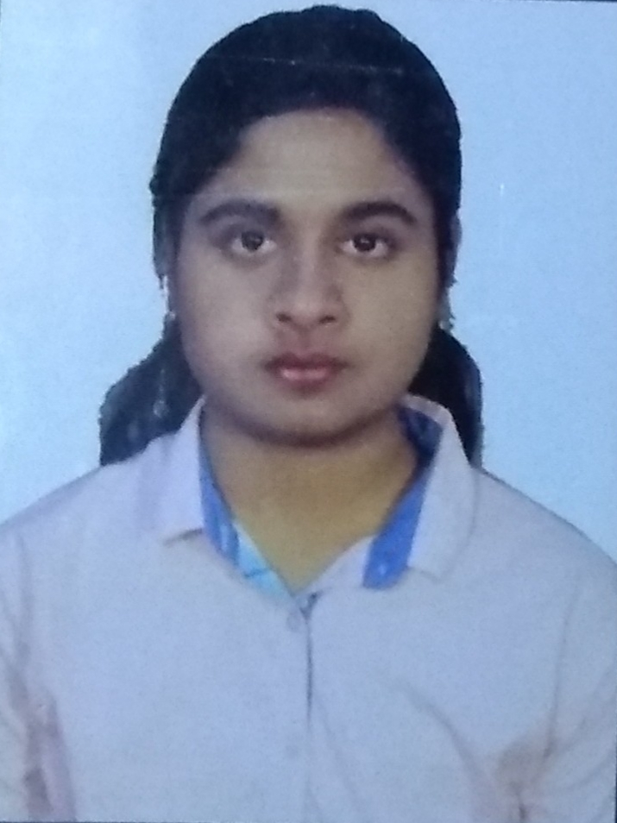

Address: Baruipur
Ukil Para
Kol- 700144

CAREER OBJECTIVE
To establish as an Engineer in an environment where I can utilize my skills and education, to become perfect in technical field.

BASIC ACADEMIC CREDENTIALS

Qualification | Board/University | Year | Percentage
B. Tech (Electronics and Communication Engineering) | MAKAUT  Gargi Memorial Institute of Technology(GMIT) | 2017-2021 | CGPA 7.67  (upto 4th semester)
10+2 | WBCHSE  Rashmoni Balika Vidyalaya | 2017 | 77.2%
10th | WBBSE  Rashmoni Balika Vidyalaya | 2015 | 85%

INDUSTRIAL TRAINING SKILLS
- Company Name : Aptech (GMIT)
Project Title : HTML
Duration : One Month.

- Company Name : Webtech
Project Title : Core Java
Duration : One Month

- Company Name : NIIT
Project Title : Data Science using Python
Duration : One Month

TECHNICAL SKILLS

- Language: CORE JAVA, C,PYTHON
- General and graphic application: HTML
- Good knowledge in :Basic Electronics , Digital electronics, Micro Processor And microcontrolller
- Microsoft Office Word, Microsoft Office Excel, Microsoft Office Power Point
- Internet Browsing

EXTRA –CURRICULAR ACTIVITIES

- Drawing,Singing

INTERPERSONAL SKILL

  - Ability to rapidly build relationship and set up trust.
  - Confident and Determined
  - Ability to cope up with different situations.

JOB EXPERIENCE

- Fresher

REFERENCES

1. Dr. Syed Samser Ali, Teacher InCharge, Dept of Electronics and communication Engineering, GMIT
2. Bipasha Chakraborty, Assistant Professor, Dept of Electronics and communication Engineering , GMIT
3. Priyanka Das, Assistant Professor, Dept of Electronics and communication Engineering, GMIT
4. Ashis Dey, Assistant Professor, Dept of Electronics and communication Engineering, GMIT

PERSONAL DETAILS

- Father’s Name : Tapas Kumar Bhattacharjee
- Permanent Address : Baruipur,Ukil Para,Kolkata-700144
- Date of Birth : 10th January, 2000
- Language Known : English & Bengali
- Marital Status : Single
- Nationality/Religion : Indian
- Interest & Hobbies : Internet browsing, drawing and listening music.

DECLARATION

I do hereby declare that the above information is true to the best of my knowledge.

Place : Kolkata
Date : 13.03.2020 Swarnali Bhattacharjee

